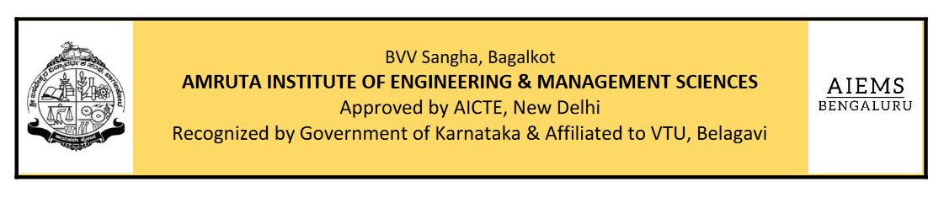

**Department of Information Science & Engineering**

**Mini Project Synopsis**

**Title: Two Wheels, Many Voices: Sentiment and Feature Analysis of Bike Reviews**

**Name:** **Simon Leo Alexander**

**USN : 1AR23IS042**

**Introduction:**

**The Bike Reviews and Customer Satisfaction Analysis** is designed to explore individuals’ experiences, preferences, and opinions regarding different bike models. This study examines overall ratings, sentiments expressed in reviews, and the key features that influence customer satisfaction, such as mileage, comfort, performance, design, and service experience. It also investigates reasons behind negative feedback, providing a comprehensive understanding of customer concerns and expectations. Additionally, it evaluates how satisfaction varies across brands and models, highlighting strengths and weaknesses from the user’s perspective. By analyzing both quantitative ratings and qualitative feedback, this project aims to provide valuable insights into consumer priorities and market trends. The findings will help customers make informed purchase decisions and support manufacturers in enhancing product quality and service delivery.

**Statement of the problem:**

**Access to the right bike is often hindered by barriers that affect purchase decisions, ownership satisfaction, and long-term usage across diverse customer groups.** For individuals ranging from first-time buyers to experienced riders, financial constraints, maintenance costs, and personal or societal preferences contribute to dissatisfaction or model rejection. The type of bike—commuter, cruiser, sports, or electric—significantly impacts user experiences, yet their effectiveness in meeting customer needs remains underexplored. The overall cost of ownership, including fuel efficiency, service charges, and spare parts, is insufficiently documented, complicating efforts to assess affordability. Satisfaction with key features such as mileage, comfort, performance, design, and after-sales service varies widely, directly influencing customer loyalty and brand perception. Support services, such as servicing networks and warranty claims, often fall short of meeting rider expectations. Additionally, data on preferences across segments like daily commuting, touring, and performance biking is limited, hindering targeted product improvements. This project aims to collect and analyze review data on these issues to inform strategies for enhancing customer satisfaction, guiding consumer choices, and supporting manufacturers in delivering better two-wheeler solutions.

**Objectives of the study:**

1. To examine customer preferences and usage patterns across different types of bikes (e.g., commuter, cruiser, sports, electric).
2. To assess the financial burden of bike ownership, including purchase cost, mileage, maintenance, and service expenses, and evaluate affordability.
3. To evaluate customer satisfaction with key features such as performance, comfort, mileage, design, and suitability for intended use (e.g., daily commute, touring, racing).
4. To investigate the adequacy of after-sales services, including servicing networks, warranty support, and availability of spare parts.
5. To analyze customer feedback on overall satisfaction and propose recommendations for improving product quality, affordability, and service delivery.

**Statement of Hypothesis:**

* **H₀ (Null Hypothesis):** Customers are not satisfied with the quality, performance, and accessibility of bikes and related services provided by manufacturers.
* **H₁ (Alternative Hypothesis):** Customers are satisfied with the quality, performance, and accessibility of bikes and related services provided by manufacturers.

**Sources of Data Collection:**

The study will utilize two primary sources of data:

* **Primary Data:** Collected via structured questionnaires or interviews from bike owners, potential buyers, and service users in [Specify City/Region]. Discussions with dealers, mechanics, and service center representatives will also provide additional insights.
* **Secondary Data:** Gathered from online customer reviews (e.g., e-commerce sites, forums), industry reports, research journals, magazines, newspapers, and company websites.

**Chapters Scheme:**

* **Chapter I**: Study Introduction
* **Chapter II**: Educational Context
* **Chapter III**: Theoretical Framework
* **Chapter IV**: Data Analysis
* **Chapter V**: Results & Recommendations

**Name:** **Simon Leo Alexander**

**USN : 1AR23IS042**